**Unit 4 lab/homework**

Please go over key concepts summary at: <https://csawesome.runestone.academy/runestone/books/published/csawesome/Unit4-Iteration/topic-4-6-summary.html>

Extra practice at (chapters 4.7-4.13 in the CSAwesome textbook. Please complete 4.7, 4.8, 4.9 before next class):

<https://csawesome.runestone.academy/runestone/books/published/csawesome/Unit4-Iteration/topic-4-7-practice-mixed-code.html>

<https://csawesome.runestone.academy/runestone/books/published/csawesome/Unit4-Iteration/topic-4-8-practice-coding.html>

<https://csawesome.runestone.academy/runestone/books/published/csawesome/Unit4-Iteration/Exercises.html>

<https://csawesome.runestone.academy/runestone/books/published/csawesome/Unit4-Iteration/FRQcalendar.html>

<https://csawesome.runestone.academy/runestone/books/published/csawesome/Unit4-Iteration/FRQselfDivisorA.html>

<https://csawesome.runestone.academy/runestone/books/published/csawesome/Unit4-Iteration/FRQstringScrambleA.html>

<https://csawesome.runestone.academy/runestone/books/published/csawesome/Unit4-Iteration/ConsumerReviewLab.html>

While loops

1. Use a while loop to print out 5 random numbers between 1 and 10
2. Generate a random number between 100 and 200. Use a while loop to find the sum of all the digits in the number. (for example, for 123 you will print 6 as 1+2+3=6)
3. Create a coin flip guessing game. Generate a random number between 0 and 1 [0 will represent heads and 1 will represent tails]. Ask the user to guess the result of the coin flip. If the user is correct let them know. If the user made the wrong guess let him have another guess.
4. Make a number guessing game:

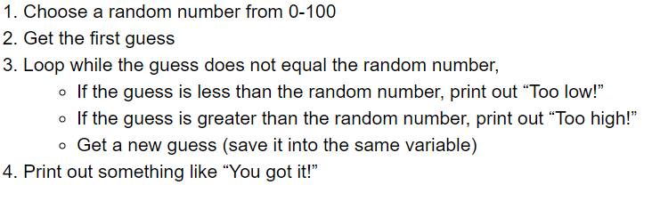

*taken from CSAwesome textbook

for loops:

1. Use a for loop to print out the numbers 7 through 19.
2. Repeat question 5 but initialize the variable outside of the for loop and put the change statement in the body of the for loop. (Similar to a while loop).
3. Use a for loop to print all numbers from 1 to 5 in descending order. (output should look like this: 54321)

Strings and loops:

1. Create a string variable with the phrase: “y0u can find m0re l00p practice in the b00k”. Use a use a loop to replace all zeros with o’s
2. Create a string variable with your name. Print out the reverse spelling of your name with the help of a loop.

Nested loops:

1. Use a nested loop to print a 10 row by 10 column Square using * signs.
2. Use a nested loop to print a right-angled triangle.
3. Use a nested loop to print an isosceles triangle.

Tracing loops:

1. Please complete trace the practice exercises at: <https://csawesome.runestone.academy/runestone/books/published/csawesome/Unit4-Iteration/topic-4-5-loop-analysis.html>

Switch:

1. Create a program which prompts the user to enter a number between 1 and 7. For each number print out its day of the week (Sunday = 1, Monday = 2, etc.)

Extra questions:

1. Have the user input 10 numbers. Use a loop to read the numbers and at the end output the largest number.
2. The Social Insurance Number (SIN) is a 9 digit number that you need to work in Canada or to have access to government programs and benefits. Create a program the prompts the user to enter his SIN and check whether its valid (entry has only digits, correct length etc.)
3. Prompt the user to enter names of three cities. Print them out in alphabetical order.
4. Compute Pi.

You can approximate pi by using the Leibniz formula:

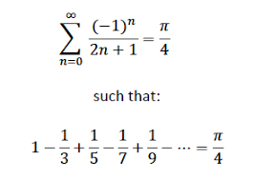

The more iterations of your loop, the more accurate the decimals you will get.